

1st November 2016

**Cambridgeshire residents offered exclusive energy rates**

The council has partnered with iChoosr, the UK’s leading expert in collective energy switching, to deliver bespoke and highly competitive energy tariffs. Now is the ideal time for residents, especially those on standard tariffs, to switch.

Residents are encouraged to register on the Cambridgeshire Energy Switch scheme to see if they can secure a good rate for the year ahead as wholesale energy prices are likely to continue to increase in the coming weeks.

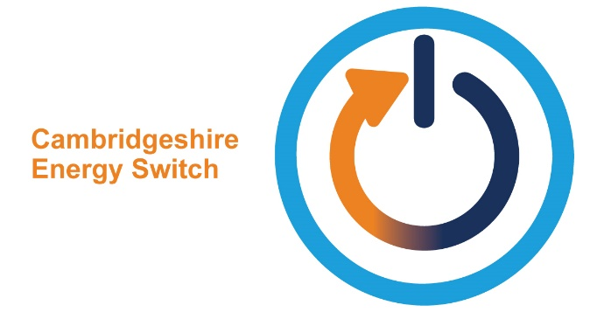

If you haven’t signed up yet to the scheme you are able to access the competitive deals secured through the collective switching by simply signing up via the website Cambridgeshire Energy Switch web link below:

[www.cambridgeshire.gov.uk/cambsenergyswitch](http://www.cambridgeshire.gov.uk/cambsenergyswitch)

Or visit Cambridgeshire County Council’s website and click on the Cambridgeshire Energy Switch logo on the front page.

You can sign right up until the offer expires on 29th November.

Two energy companies won the 11th October 2016 energy auction. Scottish and Southern Electric (SSE) and Robin Hood Energy can supply a range of contracts to residents. The SSE tariffs are exclusive to residents and are not available direct from the suppliers or via price comparison services.

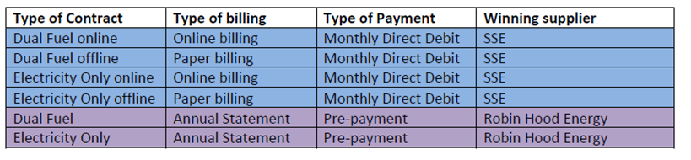

There is no obligation for people to accept an offer but if you do it’s easy and straight forward and the new provider will take care of the whole process.

The deadline to accept the offer is **Tuesday 29th November.** If you have any issues registering please contact the helpdesk on 0800 048 8285 which is open Mon-Friday 08.30am-5.30pm or contact the Energy Investment Unit at Cambridgeshire County Council on 01223 728552.